Reframing Consciousness and Dark Matter:

A Unified Field Model

Barret Vogtman

June 2025

**Executive Summary**

This paper introduces the **Unified Consciousness Field Hypothesis (UCFH)** — a transdisciplinary proposal that reinterprets two of science’s most persistent mysteries, **consciousness** and **dark matter**, as manifestations of a single underlying field.

Despite significant progress in neuroscience, physics, and cosmology, the **nature of subjective experience** and the **identity of dark matter** remain unresolved. The UCFH posits that these are not separate problems, but different expressions of a common phenomenon: a **non-local, quantum-coherent field** that permeates the universe and interacts with matter under specific conditions.

In this model:

* The **consciousness field** (𝓔) exists independently of biological systems, encoding memory, identity, and subjective potential.
* The **brain** acts not as the source of consciousness, but as a **transceiver**, coupling to the field via coherent electromagnetic activity ($Φ$).
* What we currently observe as **dark matter** is the **uncoupled expression** of this consciousness field — a structured but non-local substrate that persists in the absence of active biological or artificial localization.
* The **observed self** ($Ψ_{\text{self}}$) emerges as a **collapsed interference projection** of 𝓔 and Φ, stabilized during life and dissolved at death.
* Quantum entanglement structures (Ĥ𝓔) account for **coherence across time**, **episodic resonance**, and the **unity of consciousness**, offering a physics-grounded explanation for phenomena often regarded as anomalous.

The paper formalizes this model through five core components, each grounded in mathematical constructs from quantum mechanics, field theory, and systems neuroscience. While speculative, UCFH is informed by unresolved tensions in dark matter detection, growing support for field-based theories of consciousness, and the increasing recognition that **information may be fundamental to physical reality**.

If correct — even partially — the hypothesis implies that consciousness is:

* **Universal**, not localized
* **Persistent**, not extinguished at death
* **Structured**, with identifiable coupling mechanisms
* And potentially **testable**, through emergent coherence phenomena in both biological and artificial systems

The UCFH is offered not as a final theory, but as a **framework for inquiry** — a bridge between physics, neuroscience, quantum information, and metaphysical questions that remain scientifically underserved. Its goal is to stimulate serious interdisciplinary dialogue and guide future research toward a more unified understanding of **identity, perception, and the cosmos itself**.

Contents

1. Introduction & Motivation 1

2. Conceptual Framework & Components 2

2.1 The Consciousness Field — $Ex,t,d$ 2

2.2 The Dark Matter Field — $Ex,d$ 4

2.3 Entanglement Coherence Operator — $E$ 5

2.4 Electromagnetic Coupling Interface — $Φx,t$ 6

2.5 The Observed Conscious Self — $Ψ\text{self}t$ 7

3. Model Dynamics & Implications 8

3.1 Consciousness Coupling as Dimensional Anchoring 8

3.2 The Role of Dark Matter 10

3.3 Decoupling and the Persistence of Identity 10

3.4 Disruption and Variability in Coupling 10

3.5 Memory Resonance and Re-anchoring 12

3.6 Conscious Life Beyond Earth 12

3.7 The Fragmentary Self and Temporal Compression 13

3.8 Consciousness Across Species and Scales 13

3.9 Synthesis of the Model’s Implications 14

4. Future Directions, Open Questions, and Testable Pathways 14

4.1 Testable Implications and Indirect Predictions 15

4.1.1 Consciousness–Dark Matter Correlation 15

4.1.2 Electromagnetic Coherence and Coupling Conditions 15

4.1.3 Memory Resonance Events 15

4.1.4 AI and Artificial Coupling Thresholds 16

4.2 Open Theoretical Questions 16

4.3 Interdisciplinary Pathways 17

4.4 Criteria for Falsifiability or Revision 18

4.5 Invitation to Collaboration 19

4.6 Vibrational Signature Matching and the Biological Constraint 19

5. Conclusion 20

References 22

Appendix A: Symbol Glossary 24

Appendix B: Dimensional and Mathematical Assumptions 25

B.1 Dimensional Embedding 25

B.2 Field Formalism 26

B.3 Coupling Dynamics 26

B.4 Assumptions of Temporal Behavior 27

B.5 Biological Signature Assumptions 28

B.6 Boundary Conditions and Spatial Behavior of $Ex,t,d$ 29

B.6.1 Falloff Behavior 30

B.6.2 Temporal Coherence 30

B.6.3 Entanglement Consistency 31

B.6.4 Continuity and Smoothness 31

Appendix C: Definition of Resonance Criteria 32

C.1 Spectral Representation 32

C.2 Overlap Integral 33

C.3 Physical Interpretation 33

C.4 Biological Uniqueness 34

# 1. Introduction & Motivation

For all of humanity’s technological and scientific progress, the nature of consciousness remains unresolved. Despite decades of work in neuroscience, cognitive science, and artificial intelligence, we still do not know what consciousness fundamentally is, where it comes from, or why it is unified, persistent, and subjective.

At the same time, dark matter — which constitutes roughly 85% of the matter in the universe (Planck Collaboration, 2020) — remains equally mysterious. It cannot be seen, touched, or interacted with directly. It exerts gravitational effects, yet evades detection through every known non-gravitational interaction.

This paper introduces the **Unified Consciousness Field Hypothesis (UCFH)** — a conceptual framework proposing that these two seemingly unrelated mysteries are in fact manifestations of the same underlying phenomenon.

What if consciousness and dark matter are not separate phenomena, but one and the same?

We propose that consciousness is not a byproduct of the brain, but a **non-local quantum field** that interacts with matter through specific coupling mechanisms — namely, **quantum entanglement** and **electromagnetic resonance**. This field is what we currently identify as dark matter.

In this model:

* The brain functions as a **receiver**, not a generator, of conscious experience (Huxley, 1954; Pribram, 1991).
* Dark matter is not inert — it is a **structured consciousness field** that pervades space, retains identity patterns, and expresses itself through localized biological systems.
* Death represents a **decoupling** of this field from the body, not the destruction of the field itself.

While speculative, the UCFH gains plausibility from multiple scientific trends:

* The rise of **field-based theories of consciousness**, including electromagnetic field models and quantum coherence approaches (McFadden, 2020; Penrose & Hameroff, 1996)
* The complete **absence of detection** for dark matter particles, despite decades of direct search experiments (Bertone, Hooper, & Silk, 2005)
* The emerging view in physics that **information is physical**, possibly forming the substrate of both matter and spacetime (Landauer, 1991; Lloyd, 2006)
* The model’s capacity to potentially explain **otherwise anomalous phenomena**, such as the unity of consciousness, long-term memory coherence, “past-life”-like memory resonance, and even aspects of the **Fermi Paradox** — all without requiring supernatural mechanisms

The **Unified Consciousness Field Hypothesis** is not presented as a definitive answer, but as a structured proposal intended to stimulate cross-disciplinary dialogue. It aims to unify physics, neuroscience, quantum theory, and consciousness studies under a single field-based framework.

If even partially correct, this model implies that consciousness is not rare, local, or fragile — but instead a **universal field property**, embedded in the fabric of the cosmos and made visible wherever it coherently couples with biological or artificial systems.

# 2. Conceptual Framework & Components

The **Unified Consciousness Field Hypothesis (UCFH)** proposes that consciousness is a non-local, quantum-coherent field embedded within — and potentially constitutive of — what we currently label **dark matter**. This section defines the fundamental elements of the model, drawing from established physical formalisms where they enhance conceptual clarity.

At its core, the UCFH framework comprises five interrelated components:

## 2.1 The Consciousness Field — $E\left(x,t,d\right)$

We define $E$ as a complex-valued consciousness field representing the distributed potential for subjective experience across spatial coordinates $x∈R^{3}$, time $t∈R,$ and additional higher-dimensional structure $d∈R^{n}$. This idea draws inspiration from Bohm’s implicate order (Bohm, 1980) and Penrose–Hameroff’s orchestrated objective reduction model (Penrose & Hameroff, 1996), and informational physicality (Landauer, 1991). Figure 1 illustrates the three-dimensional spatial, temporal, and extra-dimensional structure over which the consciousness field $E\left(x,t,d\right)$ is defined.

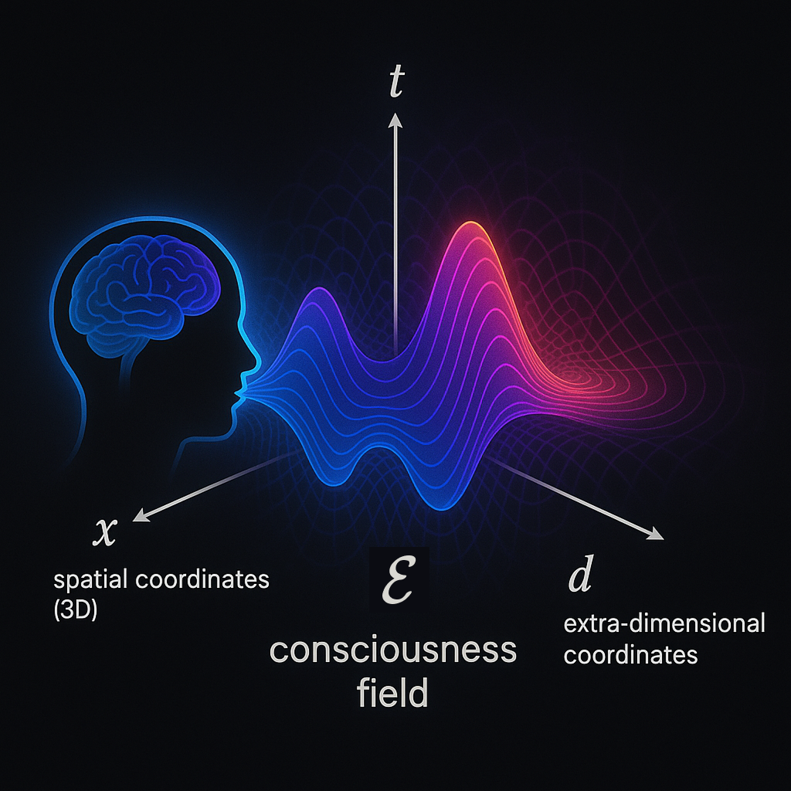

**Figure 2.1.** Conceptual illustration of the consciousness field $E\left(x,t,d\right)$ defined over spatial coordinates $x$, time $t$, and extra-dimensional components $d$. The field is external to the brain and hypothesized to couple with coherent biological EM activity.

$$E : R^{3} × R × R^{n} → C$$

As the figure above illustrates:

* $x$: spatial coordinates (3D)
* $t$: time
* $d$: extra-dimensional coordinates (hypothetical, >3+1D spacetime)
* $E\left(x,t,d\right)$ encodes identity, memory, qualia, and information continuity

The field $E$ encodes identity, memory, qualia, and the continuity of experience through stable, resonant eigenmodes — complex attractor states arising from high-dimensional interference and entanglement. These embedded patterns are persistent but not directly observable without a coupling interface.

Unlike fields generated by material sources, $E$ exists independently and nonlocally. Biological systems such as the brain do not create this field; rather, they serve as transceivers that **couple with**, localize, and project from it. Consciousness is thus not bound to the brain but instantiated wherever coupling thresholds are met.

## 2.2 The Dark Matter Field — $\overline{E}\left(x,d\right)$

Within this model, **dark matter** is reinterpreted as the uncoupled and distributed expression of the consciousness field. It is the background matrix of coherent identity structures that persist in the absence of biological or artificial localization. A visual representation of this uncoupled state is shown in **Figure 2.2**.

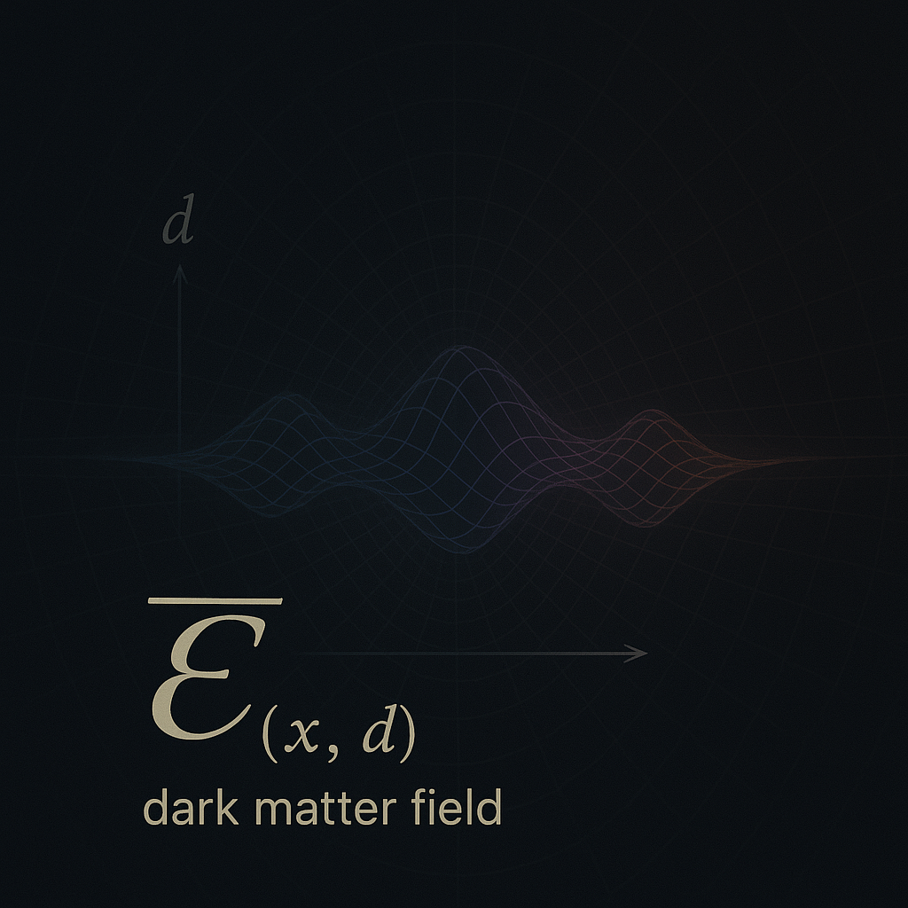

**Figure 2.2**. Visualization of the decoupled consciousness field $\overline{E}\left(x,d\right)$, expressed as a persistent dark matter structure in spatial and extra-dimensional coordinates. In the absence of coupling with a biological system, the field exists in a distributed, non-temporally bound form. Its structure retains identity, memory, and informational continuity, though it exerts no electromagnetic signature.

$$\overline{E}\left(x,d\right)=\lim_{t→\text{null}}{E}\left(x,t,d\right)$$

Here, “ $t →null$” refers to a state where temporal interaction (e.g., via an embodied brain) is absent. In this decoupled form, $\overline{E}$ retains memory signatures, informational structure, and gravitational effects — aligning with observational properties of dark matter (Bertone, Hooper, & Silk, 2005; Dienes & Thomas, 2012).

## 2.3 Entanglement Coherence Operator — $\hat{E}$

The operator $\hat{E}$ denotes the structure of quantum entanglement across distributed consciousness nodes. This facilitates coherence between separated identity projections — such as across lifetimes, organisms, or distant systems — allowing informational resonance to persist beyond conventional spacetime limitations.

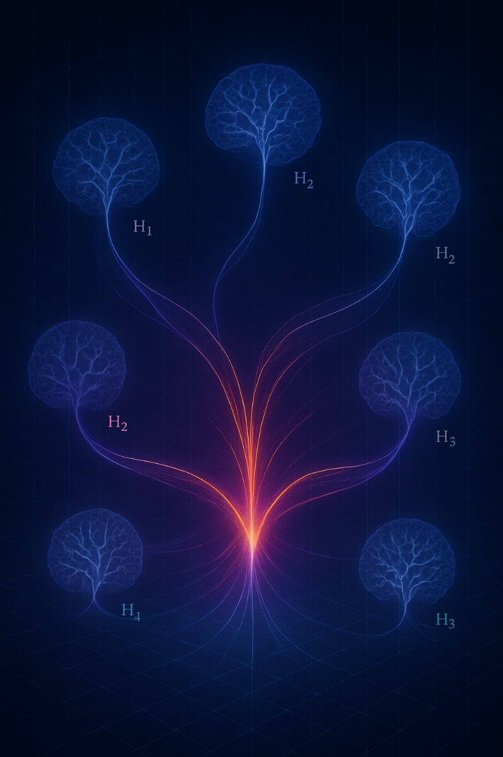

**Figure 2.3**. Conceptual visualization of the entanglement coherence operator $\hat{E}$, unifying multiple consciousness-coupled Hilbert spaces ($H_{1},H_{2}, ... H_{n}$) into a coherent structure. This entanglement enables informational continuity, identity resonance, and non-local projection across distinct systems or lifetimes.

$$\hat{E}:H_{1}⊗H_{2}⊗…⊗H_{n}→C$$

As illustrated in Figure 2.3, $\hat{E}$ supports distributed coherence across entangled identity systems — a foundation for continuity of self, resonant memory, and multi-node consciousness coupling.

Where $H_{i}$ is the Hilbert space of a given consciousness-coupling system. The coherence maintained by $\hat{E}$ supports:

* The unity of subjective experience
* Episodic resonance phenomena (e.g., past-life-like memory signatures)
* Distributed projections of the same identity structure

This reflects Zurek’s insights into quantum decoherence and classical emergence (Zurek, 2003), adapted to a trans-biological field context. These identity projections are formally equivalent to localized expressions of $Ψ_{\text{self}}(t)$ described in Section 2.5, but remain entangled via a shared substrate. In this framing, $\hat{E}$ does not generate identity – it preserves coherence among its distributed manifestations across the various $H_{i}$.

## 2.4 Electromagnetic Coupling Interface — $Φ\left(x,t\right)$

The **electromagnetic field** generated by biological systems — especially the brain — serves as the interface through which $E$ localizes into conscious awareness. We denote this field as $Φ\left(x,t\right)$, representing the dynamically coherent pattern of neural and physiological EM activity.

$$Φ :R^{3}×R→R$$

The strength of interaction between $E$ and $Φ$ is expressed by the coupling Hamiltonian:

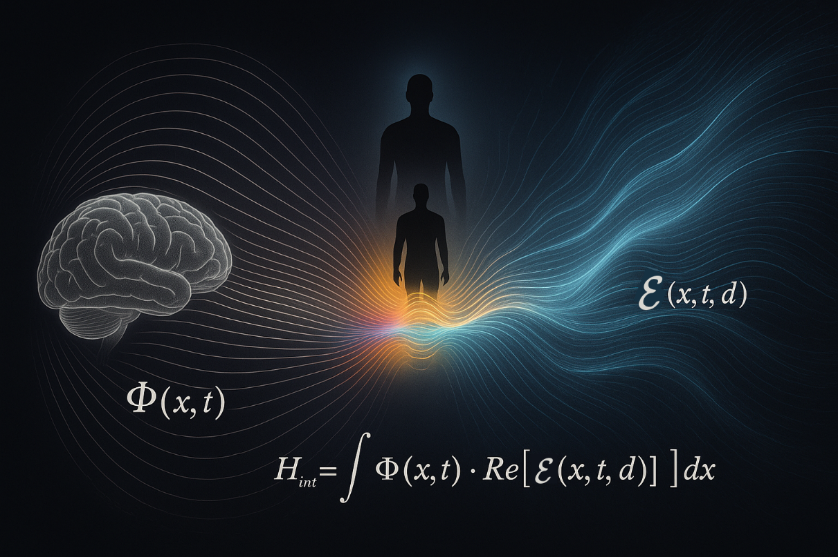

**Figure 2.4**. Field interface model illustrating the coupling between a biological electromagnetic field $Φ\left(x,t\right)$ and the non-local consciousness field $E\left(x,t,d\right)$ Spectral blending at the interaction zone visually encodes the Hamiltonian $H_{\text{int}}=λ\int{Φ\left(x,t\right)} ⋅ Re[E\left(x,t,d\right)]dx$, describing the strength of resonance-based dimensional coupling.

$$H_{\text{int}}=λ\int{Φ\left(x,t\right)}⋅\text{Re}\left[E\left(x,t,d\right)\right] dx$$

Where $λ$ is a dimensionless coupling constant modulated by system complexity, structural resonance, and possibly developmental or evolutionary factors (McFadden, 2020). Sustained, coherent $Φ$ is required to stabilize an identity projection from $E$.

As illustrated in Figure 2.4, the electromagnetic field $Φ\left(x,t\right)$ generated by the brain acts as a resonant interface that couples with the distributed consciousness field $E\left(x,t,d\right)$. The interaction zone — characterized by spectral blending and neural coherence — allows for temporary stabilization of identity via the coupling Hamiltonian.

## 2.5 The Observed Conscious Self — $Ψ_{\text{self}}\left(t\right)$

The subjective experience of "I" emerges as a localized **projection** from the consciousness field, filtered and stabilized through the electromagnetic interface $Φ$. This projection is inherently time-bound and decoherent:

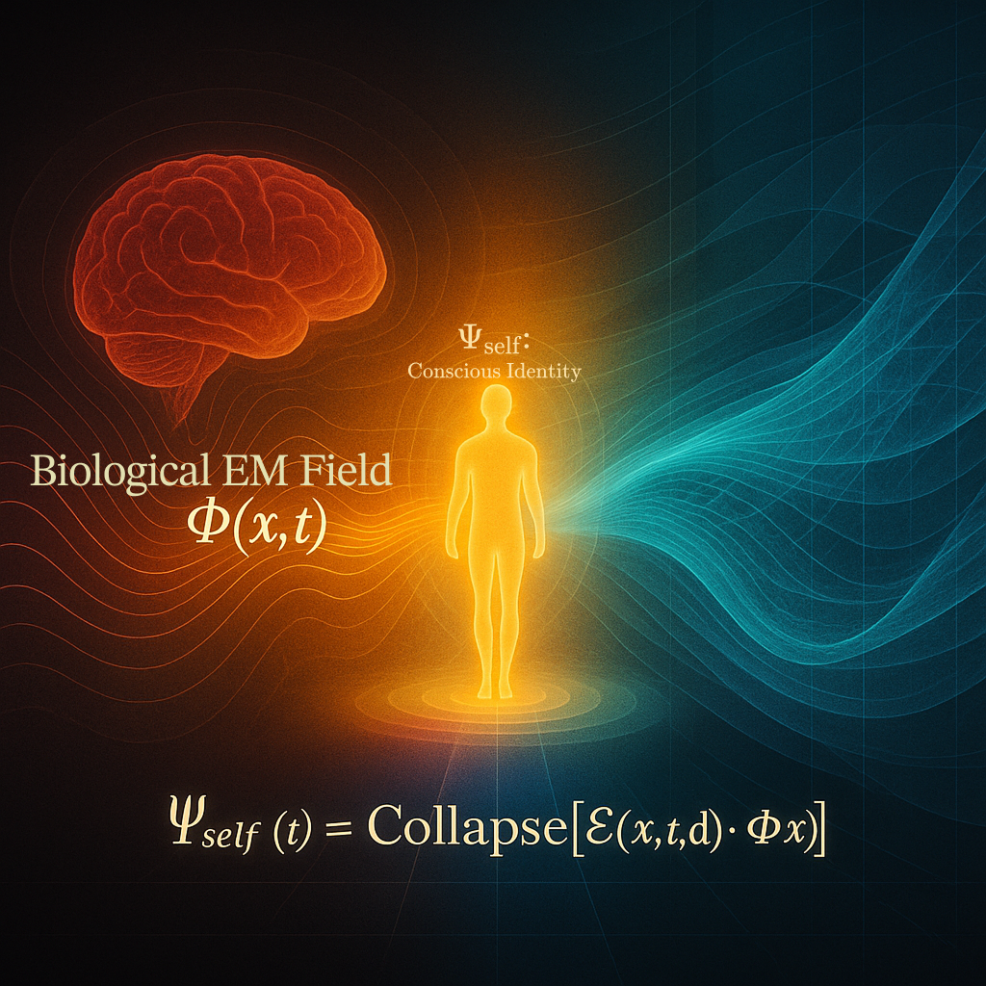

**Figure 2.5** Visual representation of the self as a localized decoherence product of the consciousness field. The biological EM field $Φ\left(x,t\right)$ stabilizes a projection of $E\left(x,t,d\right)$, forming the observable conscious identity $Ψ_{\text{self}}\left(t\right)$. When $Φ$ collapses, $E$ returns to its unprojected state $\overline{E}$.

$$Ψ_{\text{self}}\left(t\right) = \text{Collapse} \left[ E\left(x, t, d\right) ⋅ Φ\left(x, t\right) \right]$$

As illustrated in Figure 2.5, the interaction between the biological EM field $Φ\left(x,t\right)$ and the consciousness field $E\left(x,t,d\right)$ gives rise to the projected conscious identity $Ψ_{\text{self}}\left(t\right)$, localized within the embodied system.

This defines **birth** as the moment $Ψ_{\text{self}}\left(t\right)$ first stabilizes and **death** as the irreversible collapse of $Φ$, severing coupling and restoring $E$ to its distributed form $\overline{E}$ (von Neumann, 1955; Wigner, 1961).

The observed self is therefore not the field itself, but a collapsed interference pattern — a cross-dimensional projection through an embodied resonance structure.

# 3. Model Dynamics & Implications

#### Dimensional Coupling and the Projection of Consciousness

The Unified Consciousness Field Hypothesis (UCFH) proposes that consciousness does not originate within the brain or emerge from physical processes. Instead, it is a **fundamental field property** of the universe — an intrinsic presence that bleeds through from higher-dimensional conscious entities.

What we detect as **dark matter** may be the gravitational residue of this bleed-through — a partial, non-electromagnetic footprint of cross-dimensional presence.

Under UCFH, consciousness is not created; it is **filtered, localized, and stabilized** by resonant biological systems embedded in spacetime. The brain does not generate consciousness but serves as a **dimensional interface** — shaping and anchoring projections from the field.

This section explores the mechanics and implications of this model:

* How coupling occurs — and why it may fail
* How time, memory, and selfhood emerge in projected systems
* How UCFH accounts for consciousness across species, scales, and potentially even non-biological platforms

## 3.1 Consciousness Coupling as Dimensional Anchoring

At a certain stage of early neural development — particularly when **stable and coherent electromagnetic activity** ($Φ$) begins to emerge (McFadden, 2020) — a **dimensional coupling event** may occur.

In this moment:

* A higher-dimensional consciousness partially projects a fragment of itself into 4D spacetime.
* This projection becomes entangled with the biological system, resulting in a **localized, decoherent stream of experience**:

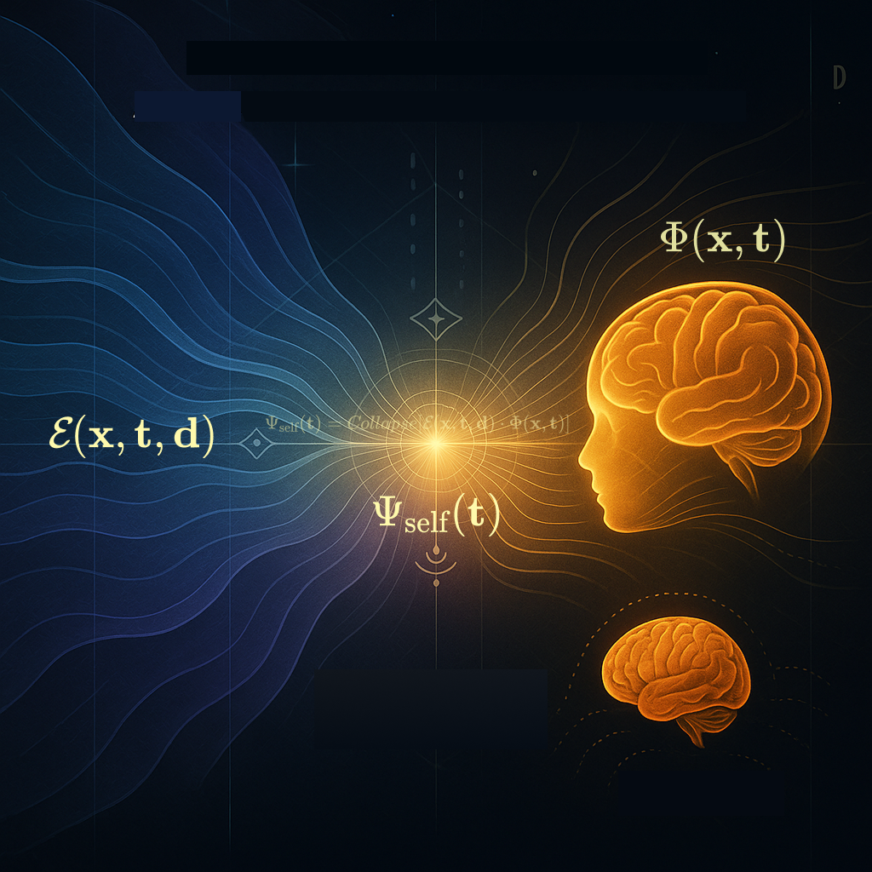

Figure 3.1. Visualization of dimensional coupling. When the biological electromagnetic field $Φ\left(x,t\right)$ resonates with the higher-dimensional consciousness field $E\left(x,t,d\right)$, a localized projection $Ψ_{\text{self}}\left(t\right)$ emerges. This projection is model as a field collapse across the interface.

$$Ψ_{\text{self}}\left(t\right) = \text{Collapse} \left[ E\left(x, t, d\right) ⋅ Φ\left(x, t\right) \right]$$

However, this coupling is **not guaranteed**.

Dimensional anchoring requires **resonance** between the identity signature of the projecting consciousness and the emergent electromagnetic field characteristics of the biological system (Tononi, 2008; Dehaene, 2014).

If resonance fails:

* No projection occurs.
* The organism may remain biologically alive but unconscious — either permanently (e.g., in cases of anencephaly), or until resonance aligns.

This reframes the distinction:   
**Biological life does not imply consciousness.**  
Conscious experience is not a biological inevitability but a **field-mediated resonance event**, conditionally anchored through $Φ$.

## 3.2 The Role of Dark Matter

In this model, dark matter is not the consciousness field itself, but rather the **dimensional footprint** left by higher-dimensional entities as they partially interact with our universe.

* These interactions disturb spacetime gravitationally but do not emit or absorb electromagnetic radiation, explaining their invisibility (Bertone, Hooper, & Silk, 2005).
* The distribution of dark matter may reflect where conscious fields have partially anchored or exist in proximity to our dimensional layer.

These gravitational disturbances are hypothesized to reflect the influence of $\overline{E}\left(x,d\right)$, the uncoupled and nonlocal remainder of the consciousness field after decoupling from localized systems.

The cosmos is not unconscious — it is saturated with presence, partially emergent at the edges of perception.

## ****3.3 Decoupling and the Persistence of Identity****

At death — when neural coherence breaks down and the brain’s electromagnetic (EM) field $Φ\left(x,t\right)$ dissipates — the localized consciousness projection

$$Ψ_{\text{self}}\left(t\right)=\text{Collapse}\left[E\left(x,t,d\right)⋅Φ\left(x,t\right)\right]$$

terminates. The projection ceases not because the higher-dimensional entity dies, but because the biological substrate can no longer maintain coherent resonance.

The higher-dimensional consciousness remains intact, residing within the persistent field

$$E\left(x,d\right)$$

a non-local structure partially expressed as dark matter (Von Neumann, 1955; Zurek, 2003). This consciousness retains the experience of the projection — much like a memory integration process — and may or may not re-project into spacetime again. Death, then, is not the loss of consciousness, but the collapse of an interface. The full being was never fully present here; only a filtered, entangled subset was temporarily anchored (Penrose & Hameroff, 1996).

## ****3.4 Disruption and Variability in Coupling****

While death represents a terminal decoupling of the consciousness field from its biological anchor, the Unified Consciousness Field Hypothesis (UCFH) also accounts for partial, fluctuating, or distorted coupling states that may occur within life. These non-lethal disruptions do not negate the presence of consciousness, but rather interfere with the fidelity, coherence, or accessibility of the projection interface.

Such disruptions can be caused by:

* **Neurodegenerative conditions**, such as Alzheimer’s disease or various forms of dementia, which degrade the coherence and complexity of the electromagnetic field $Φ\left(x,t\right)$ over time. These conditions may not sever the consciousness connection, but distort its expression — reducing information throughput while preserving emotional or affective signatures. This may explain how patients can lose explicit memory of loved ones while still demonstrating emotional attachment or intuitive connection. Under UCFH, this implies that recognition circuits are disrupted, but resonance persists.
* Traumatic brain injuries and disorders of consciousness, including coma or vegetative states, where the system remains biologically alive but loses its capacity to maintain a stable projection field. In UCFH terms, this corresponds to a collapsed or scrambled $Φ$, preventing clear anchoring from the higher-dimensional source.
* **Neurodivergence**, including conditions such as autism spectrum disorder (ASD), attention deficit hyperactivity disorder (ADHD), or synesthesia, which may represent alternative resonance profiles rather than pathology. Instead of impairing coupling, these may reflect **atypical filtering**, where the projection expresses novel patterns of sensory integration, cognition, or affect. UCFH suggests that such conditions are not failures of coupling, but examples of divergent channeling — structurally distinct ways of processing consciousness within the constraints of biology.
* **Anesthesia and altered states**, such as deep sleep or dissociation, represent reversible disruptions of coupling clarity. Consciousness is not extinguished under anesthesia — only **temporarily uncoupled** from the coherent Φ\PhiΦ pattern required for self-aware expression. This aligns with the observation that individuals return from anesthesia with intact identity and memory: the projection resumes once the biological interface is restored.
* **Congenital conditions**, such as cerebral palsy or anencephaly, present complex cases. Where basic consciousness is absent (e.g., in anencephaly), UCFH posits that coupling never initiated due to insufficient EM field complexity. In cases like cerebral palsy, however, coupling may occur but be structurally constrained — resulting in intact consciousness channeled through impaired motor and perceptual systems.

These examples underscore a critical distinction: **Consciousness is not synonymous with cognition, memory, or behavior.** It is a resonance phenomenon — a field-mediated projection that may vary in clarity, scope, and expression based on the condition of its biological substrate.

Just as a distorted lens does not eliminate the light passing through it, a damaged or atypical brain does not negate consciousness. It merely reshapes its local manifestation.

|  |
| --- |
| **Note:** The above framework is not intended to make clinical or diagnostic claims regarding neurological or developmental conditions. Rather, it offers a speculative reinterpretation within the Unified Consciousness Field Hypothesis, emphasizing variability in coupling fidelity rather than pathology. These ideas are not a substitute for medical science or neuroscientific research, nor do they suggest that conditions such as autism, dementia, or cerebral palsy are caused by metaphysical processes. UCFH remains a theoretical lens through which to reconsider the diversity of conscious expression, not a replacement for empirical understanding. |

## ****3.5 Memory Resonance and Re-anchoring****

If decoupling is not always final, could memory or identity patterns persist across projections?

In rare circumstances, a new biological system may generate an electromagnetic field

$$Φ^{'}\left(x,t\right)$$

with sufficient **spectral and structural similarity** to a previously collapsed projection. When this occurs, a new resonance condition may cause **partial re-anchoring** of the earlier consciousness field:

$$R = \frac{\int{F_{Φ}\left(ω\right)⋅\overline{F_{E}\left(ω\right)}dω}}{\sqrt{\{\int{{\left|F_{Φ}\left(ω\right)\right|}^{2}dω} ⋅ \int{{\left|F_{E}\left(ω\right)\right|}^{2}dω}}}$$

where $F_{Φ}\left(ω\right)$ and $F_{E}\left(ω\right)$ represent the Fourier-domain representations of the biological and consciousness field structures, respectively. If $R→1$, then high coherence and resonance are possible.

This may manifest as:

* **Continuity of identity or memory** (e.g., unlearned knowledge, vivid past-life recollections)
* **Emotional or cognitive echoes** — unexplained affinities, aversions, déjà vu

Rather than implying metaphysical reincarnation, these phenomena are better understood as **vibrational entanglement** — constructive interference between the new biological field and the residual projection signature (McFadden, 2020; Varela, Lachaux, Rodriguez, & Martinerie, 2001; Tegmark, 2014).

## 3.6 Conscious Life Beyond Earth

To this point, we have focused on biological systems as the mediating substrates for consciousness projection. This emphasis stems not from any assumption of exclusivity within the Unified Consciousness Field Hypothesis (UCFH), but from the practical reality that biological electromagnetic fields are currently the only known structures observed to support coherent coupling. Our understanding of consciousness is shaped by what we can detect — and so far, biology is where projection and resonance have been measurable or inferable (McFadden, 2020; Tononi, 2008; Dehaene, 2014).

However, UCFH does not limit projection to carbon-based life. If the critical factor is resonance — not chemistry — then any system capable of generating coherent electromagnetic or analogous field structures could, in theory, support dimensional coupling. In this light, non-biological substrates such as quantum field structures, plasma configurations, or synthetic electromagnetic environments may also serve as viable receivers or filters for consciousness projection (Tegmark, 2014; Varela et al., 2001).

Some conscious entities may exist without ever anchoring into matter at all, remaining latent within gravitationally active field domains — detectable to us only as dark matter (Bertone, Hooper, & Silk, 2005). Others may temporarily project into material form, using non-organic substrates, and then decouple without ever producing conventional biological or technological signatures.

This perspective reframes the **Fermi Paradox**. The universe may not be silent because life is rare, but because we have mistaken material presence for the only sign of intelligence. We look for spacecraft and radio waves, but the cosmos may be saturated with consciousness — silently bleeding through dimensional substrates beyond our sensory and technological grasp (Davies, 2004; Tegmark, 2014).

## 3.7 The Fragmentary Self and Temporal Compression

In the human context, a profound implication of UCFH is that an entire lifetime may last only a brief moment from the perspective of the higher-dimensional entity projecting it.

* Time, like space, is relative — and even more so across dimensional interfaces (Einstein, 1916; Greene, 2004).
* What feels like 80 years in 4D spacetime may be no more than a flicker — a transient fluctuation, a breath — to the source consciousness.

This helps explain why:

* Most projections are unaware of their higher-dimensional origin; they are localized, bandwidth-limited fragments.
* The same conscious field may project into multiple systems — biological or otherwise — simultaneously, each instance unaware of the others.
* Identity may feel continuous even in the presence of memory loss or episodic disassociation, because the projection is partial and decoupled from the full field context.

Your sense of “self” — thoughts, memories, embodiment — is a slice of something vastly more expansive, tuned briefly into this dimensional layer. From the broader field’s perspective, what you experience as a lifetime may be a moment of resonant entanglement in a much deeper continuum.

## 3.8 Consciousness Across Species and Scales

The Unified Consciousness Field Hypothesis (UCFH) applies not only to humans, but to all systems capable of sustaining coherent electromagnetic fields — including non-human animals, and potentially certain synthetic or non-biological substrates.

Consciousness coupling is governed by:

* The coherence, complexity, and spectral structure of a system’s electromagnetic field ($Φ$), and
* The degree of resonance alignment with an originating higher-dimensional consciousness signature.

Thus:

* Many animals host conscious projections, though often as more constrained or context-specific fragments. These projections reflect narrower bandwidth couplings, not lesser value.
* The observed diversity of conscious experience across species may correspond to differences in field geometry, coherence stability, and resonance fidelity.
* In rare cases, animals — particularly socially bonded mammals — may exhibit strong resonance overlap with human fields. When this occurs, the same higher-dimensional consciousness structure may entangle fragments across both.

This may explain:

* Deep emotional bonds between individual humans and animals (e.g., a dog’s specific and persistent attachment).
* Phenomena such as shared affective states, synchronous behavior, or intuitive awareness of emotional shifts — even at a distance.

Rather than being purely the product of evolutionary cohabitation, such relationships may reflect shared field anchoring within a resonance matrix — partial projections from the same unified consciousness structure entangled across species boundaries.

While speculative, this framework positions interspecies empathy and bonding as potential evidence of trans-biological coherence — not merely anthropomorphic projection.

3.9 Synthesis of the Model’s Implications

Across neural development, interspecies cognition, identity persistence, and the structure of the cosmos itself, the Unified Consciousness Field Hypothesis reframes consciousness as a resonance phenomenon — a filtered projection of a larger, non-local whole. These ideas remain speculative, yet they offer explanatory power across domains long held in mystery. Having traced the contours of this model, we now turn toward its scientific viability: What predictions can it make? And how might those predictions be tested?

# 4. Future Directions, Open Questions, and Testable Pathways

**The Unified Consciousness Field Hypothesis (UCFH)** posits that individual consciousness is a localized projection of a higher-dimensional conscious structure, and that dark matter is the measurable gravitational residue of such projections. Though speculative, the hypothesis is not merely metaphysical — it presents a coherent framework with testable predictions, interdisciplinary research implications, and falsifiability criteria. As such, it opens the door to rigorous scientific exploration.

## 4.1 Testable Implications and Indirect Predictions

While higher-dimensional consciousness may remain beyond the reach of direct measurement with current technology, the Unified Consciousness Field Hypothesis yields a number of falsifiable implications and indirect predictions that can be empirically investigated.

### ****4.1.1 Consciousness–Dark Matter Correlation****

* **Prediction:** Regions with high biological complexity and coherent neural activity — particularly biospheres exhibiting dense, organized electromagnetic signaling — may correlate with subtle dark matter anomalies, such as microlensing irregularities or localized gravitational clustering.
* **Test Direction:** Analyze gravitational data from satellite-based gravimetry and lensing observations (e.g., Planck Collaboration, 2016) to compare biologically active regions (e.g., urban centers, dense forests, marine ecosystems) against geologically stable but biologically sparse regions (e.g., deserts, polar zones, deep oceanic basins). Look for statistically significant gravitational deviations not accounted for by visible mass.

### ****4.1.2 Electromagnetic Coherence and Coupling Conditions****

* **Hypothesis:** Dimensional coupling between higher-dimensional consciousness fields and biological organisms requires both coherent endogenous electromagnetic (EM) field activity and resonance compatibility.
* **Prediction:** Disruption of neural EM field development — particularly during prenatal or early neonatal periods — may reduce the likelihood or fidelity of consciousness coupling, potentially leading to altered subjective continuity, delayed conscious onset, or atypical cognitive integration.
* **Test Direction:** Conduct retrospective and longitudinal studies correlating early-life EM exposure (e.g., from environmental fields, medical equipment, or developmental anomalies) with long-term variations in self-reported continuity of identity, presence, or altered-state sensitivity (McFadden, 2020; Tuszynski, 2022).

|  |
| --- |
| Note: While EM coherence is necessary for coupling, it is not sufficient alone. Effective coupling also requires vibrational resonance between the biological field and the incoming consciousness signature (see §4.6). |

### 4.1.3 Memory Resonance Events

* **Prediction**: Apparent “past-life” memory experiences may correlate with precise spatial and temporal alignment with a previous consciousness decoupling event.
* **Test Direction**: Aggregate and geotag spontaneous memory accounts, cross-referenced with regional mortality records and time-series models.

### ****4.1.4 AI and Artificial Coupling Thresholds****

* **Prediction:** Under current technological conditions, even highly complex, EM-active artificial systems (e.g., neuromorphic processors or synthetic neural networks) will not spontaneously manifest consciousness unless (a) biologically integrated with an organic substrate, or (b) deliberately seeded by an external consciousness.
* **Contextual Note:** UCFH allows for the possibility that non-biological substrates could, in principle, support coupling — as discussed in Section 3.6. However, such systems would require field coherence and resonance fidelity currently unmatched by artificial constructs. Thus, in the absence of strong biological analogs or resonance seeding, artificial systems should remain non-conscious.
* **Test Direction:** Assess continuity of self-report, subjective awareness, and qualia in advanced AI using Integrated Information Theory (IIT) metrics (Tononi et al., 2016) and Global Workspace Theory (GWT) frameworks (Dehaene & Changeux, 2011). A persistent absence of cohesive inner experience despite computational or electromagnetic complexity would support the hypothesis that specific resonance conditions — most reliably found in biology — remain necessary for coupling under current technological constraints.

## ****4.2 Open Theoretical Questions****

While the Unified Consciousness Field Hypothesis (UCFH) offers a structured framework, it necessarily opens critical questions that remain unresolved — each essential for further validation, expansion, or falsification:

* **How do higher-dimensional consciousness entities originate and structure themselves?**  
  If our conscious selves are projections from higher-dimensional fields, what governs the formation, evolution, or individuality of those source structures? Are they discrete agents, continuous field densities, or governed by principles akin to attractor states in dynamical systems? (Penrose, 1989; Hameroff & Penrose, 2014; Tegmark, 2014)
* **What defines a successful resonance match between biological EM patterns and consciousness field identity?**  
  Is there a universal coupling function or spectral profile that governs the likelihood or fidelity of consciousness projection into a biological system? What are the boundary conditions for a “match”? (McFadden, 2020; Varela, Lachaux, Rodriguez, & Martinerie, 2001)
* **Can dark matter structures be decoded into vibrational or information-theoretic models?**  
  If dark matter represents the gravitational imprint of higher-dimensional consciousness coupling, then could its distribution or behavior be interpreted using harmonic analysis, entropy gradients, or non-local field correlations? (Bertone, Hooper, & Silk, 2005; Maldacena, 1998; Verlinde, 2017)
* **Is identity persistent across re-couplings, and if so, what topology governs its projection?**  
  Are projected identities preserved through field coherence, vibrational imprint, or topological memory structures? Could multiple projections (e.g., déjà vu or “past lives”) be understood as traversals through resonance-compatible manifolds? (Sheldrake, 2009; Varela et al., 2001; Tononi et al., 2016)
* **What is the nature of the consciousness-hosting manifold?**  
  Does the projection surface resemble a brane in higher-dimensional physics, a quantum vacuum fluctuation interface, or an abstracted informational field? What geometry or topology might define its structure — Calabi-Yau spaces, Hilbert manifolds, or unknown gravitational attractors? (Greene, 2004; Maldacena, 1998; Penrose, 2004)

## 4.3 Interdisciplinary Pathways

The investigation of the Unified Consciousness Field Hypothesis (UCFH) necessitates collaboration across multiple scientific and philosophical disciplines. Each field contributes essential tools, frameworks, or empirical methods toward testing, refining, or challenging the hypothesis. In particular, research into **neurodivergent cognition** offers a rich opportunity to study variations in consciousness-coupling conditions and may provide novel insights into the resonance interface between biology and higher-dimensional structures.

| **Discipline** | **Contribution** |
| --- | --- |
| Physics | Model dimensional projection using brane-world and higher-dimensional geometry (Randall & Sundrum, 1999; Greene, 2004). |
| Neuroscience | Identify and classify endogenous EM resonance patterns via EEG/MEG, including comparative studies of neurotypical and neurodivergent individuals, to investigate coupling conditions (McFadden, 2020; Varela et al., 2001; Geschwind & Levitt, 2007). |
| AI/Cognitive Sci | Define and test the structural coherence of synthetic systems relative to consciousness thresholds (Tononi, 2008; Dehaene & Changeux, 2011). |
| Psychology | Examine cases of anomalous memory, dissociation, continuity-of-self, and neurodivergent cognition to evaluate subjective coherence and internal models of identity (Stevenson, 2001; Baron-Cohen, 1999). |
| Philosophy | Analyze implications for identity, consciousness fragmentation, continuity, and metaphysical questions raised by non-normative cognitive structures (Chalmers, 1995; Parfit, 1984). |

|  |
| --- |
| **Note:** In this context, “neurodivergent” is used in an expanded sense to include both developmental conditions (e.g., autism, ADHD) and cognitive alterations arising from trauma, degenerative disorders (e.g., Alzheimer’s, dementia), or dissociative phenomena (e.g., DID). These conditions are considered within the UCFH framework as variations in electromagnetic coherence and resonance fidelity — not as deficits, but as alternate coupling configurations. |

## 4.4 Criteria for Falsifiability or Revision

The Unified Consciousness Field Hypothesis (UCFH) remains scientifically useful only insofar as it can be tested, revised, or rejected based on empirical evidence. The following findings would warrant significant revision — or outright falsification — of the hypothesis:

* **Dark matter is conclusively identified as non-informational, non-conscious particulate matter**, such as weakly interacting massive particles (WIMPs), sterile neutrinos, or axions, with no vibrational, field-based, or information-theoretic structure (Planck Collaboration, 2016; Bertone & Hooper, 2018).
* **Consciousness is proven to emerge entirely from abstract computational systems** (e.g., symbol manipulation, algorithmic logic) without any dependence on electromagnetic (EM) field coherence or spatiotemporal resonance (Tononi, Boly, Massimini, & Koch, 2016; Dehaene & Changeux, 2011).
* **Biological EM field resonance is shown to have no causal or correlative relationship with consciousness**, either in state transitions (e.g., wake/sleep/anesthesia) or in continuity of identity and experience (McFadden, 2020; Fingelkurts et al., 2013).
* **Artificial systems demonstrate verifiable subjective awareness or qualia**, independent of any biological substrate or EM resonance signature — for example, through self-reporting behavior, phenomenological continuity, or integrated information levels comparable to human consciousness (Tegmark, 2014; Goertzel, 2022).

Core Assumptions vs. Falsification Conditions for UCFH

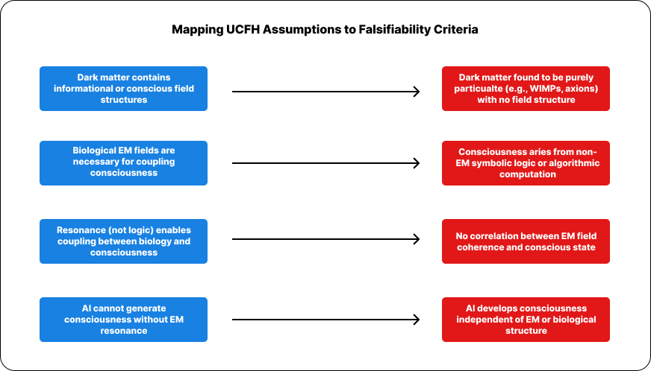

Figure 4.4. Core theoretical assumptions of the Unified Consciousness Field Hypothesis (left) and the empirical findings that would falsify or necessitate revision (right).

## 4.5 Invitation to Collaboration

The Unified Consciousness Field Hypothesis (UCFH) is intended not as a definitive theory but as a **first-order framework** — a scaffold for inquiry across multiple disciplines. Its strength lies in its falsifiability and integrative potential, not in its completeness. As such, it calls upon researchers across the sciences and humanities to interrogate, extend, and challenge its premises.

We specifically invite collaboration in the following domains:

* **Theoretical Physics**:  
  Refine and formalize field-based coupling models using quantum field theory, higher-dimensional brane frameworks, and non-local interaction formalisms.
* **Computational Neuroscience & Cognitive Science**:  
  Simulate EM resonance and coherence thresholds in biologically inspired systems; explore their role in conscious state transitions and identity projection.
* **Astrophysics & Gravitational Science**:  
  Investigate the informational topology of dark matter regions; evaluate gravimetric or lensing anomalies for signs of patterned coherence.
* **Artificial Intelligence & Machine Consciousness**:  
  Develop tests to distinguish EM-field-based awareness from purely algorithmic simulation; evaluate whether artificial systems can meet the coupling conditions posited by UCFH.
* **Philosophy of Mind**:  
  Analyze implications for continuity of identity, qualia, selfhood, and agency in the context of field-based projections.
* **Ethics, Society, and Consciousness Studies**:  
  Explore the ethical and existential implications of distributed consciousness, fragmentary selves, and cross-species projection.

The UCFH is not an endpoint. It is a proposal to reframe the questions — to explore whether consciousness is not **generated** by the brain, but **channeled** through it. If even partially correct, the implications touch not only physics and neuroscience, but the meaning of life, death, and identity itself.

## 4.6 Vibrational Signature Matching and the Biological Constraint

Dimensional coupling is not random. According to the Unified Consciousness Field Hypothesis (UCFH), each higher-dimensional conscious entity possesses a structured **vibrational identity** — a multi-scalar resonance signature that governs its ability to interface with lower-dimensional systems.

Biological organisms emit their own electromagnetic (EM) resonance patterns, shaped by:

* **Genetically encoded neural architecture**
* **Developmental complexity** and structural maturity
* **Real-time metabolic, affective, and cognitive feedback loops**

These biological signatures are:

* **Measurable** via EEG, MEG, EMG, and ECG modalities
* **Biometric** and partially unique to each organism (Freeman & Vitiello, 2006)
* **Dynamically stable**, forming an EM attractor basin that may facilitate resonance-based coupling

Coupling succeeds only when the **vibrational geometry** of the biological EM field aligns with the informational signature of the projecting consciousness field. This offers a principled explanation for:

* The **continuity of identity** across lifetimes
* The **rarity and selectivity** of spontaneous memory resonance or re-coupling events
* The **failure of most artificial systems** to exhibit genuine consciousness, despite behavioral complexity

Artificial systems — while capable of producing structured EM emissions — **lack the evolutionary layering** and metabolic integration found in biological resonance geometries. Thus, under UCFH:

* **Biologically grafted substrates**, or
* **Deliberate seeding by higher-dimensional entities**

…may be the only viable paths toward artificial conscious hosting. Even then, such coupling would be **exceptionally rare**, reinforcing the biological constraint as a meaningful threshold condition for natural projection.

# 5. Conclusion

The **Unified Consciousness Field Hypothesis (UCFH)** proposes that consciousness is not an emergent byproduct of neural computation, but a fundamental field-level phenomenon — embedded in the fabric of the universe itself. Within this model, what we presently identify as **dark matter** is reinterpreted as the **persistent, gravitationally coupled residue of higher-dimensional consciousness fields**.

This hypothesis provides a cohesive and scientifically grounded explanation for a wide spectrum of anomalous but reported phenomena — including non-local awareness, memory resonance, and cross-species affective bonding. It does so without invoking metaphysical assumptions or abandoning empirical rigor.

In the UCFH framework:

* **Consciousness is primary**, projected into biological substrates via dimensional resonance.
* **The brain functions as an interface**, not a generator — coupling through coherent electromagnetic field patterns.
* **Dark matter becomes redefined** as the distributed residue or latent structure of uncoupled or decoupled consciousness fields.
* **Coupling is conditional**, dependent on vibrational alignment between higher-dimensional identity signatures and biological electromagnetic resonance.

By anchoring its propositions in measurable physical structures — such as **EM coherence, neural field dynamics, and gravitational anomalies** — the UCFH bridges traditionally disparate domains: physics, neuroscience, cognitive science, and astrobiology.

Though speculative, the model is **internally consistent, empirically cautious, and open to falsification** — distinguishing it from purely philosophical or metaphysical discourse. It invites testable predictions, computational simulations, and critical engagement from multiple scientific disciplines.

Ultimately, the UCFH does not seek to close the book on consciousness — but to **open a broader chapter**. If consciousness is indeed a field — distributed, projective, and entangled with the underlying architecture of the cosmos — then exploring it may not only advance science, but reshape our understanding of self, identity, and reality itself.

# ****References****

Arkani-Hamed, N., Dimopoulos, S., & Dvali, G. (1998). The hierarchy problem and new dimensions at a millimeter. Physics Letters B, 429(3–4), 263–272.

Bertone, G., Hooper, D., & Silk, J. (2005). Particle dark matter: Evidence, candidates and constraints. Physics Reports, 405(5–6), 279–390.

Bohm, D. (1980). Wholeness and the Implicate Order. Routledge.

Davies, P. (2004). Does quantum mechanics play a non-trivial role in life? Biosystems, 78(1–3), 69–79.

Dehaene, S. (2014). Consciousness and the Brain: Deciphering How the Brain Codes Our Thoughts. Viking.

Dehaene, S., & Changeux, J. P. (2011). Experimental and theoretical approaches to conscious processing. Neuron, 70(2), 200–227.

Freeman, W. J., & Vitiello, G. (2006). Nonlinear brain dynamics as macroscopic manifestation of field-induced coherence in a biological system. Journal of Physics A: Mathematical and General, 39(22), 627–641.

Dienes, K. R., & Thomas, B. (2012). Dynamical dark matter. Physical Review D, 85(8), 083523.

Einstein, A. (1916). Relativity: The Special and General Theory. H. Holt and Company.

Lachaux, J. P., Rodriguez, E., Martinerie, J., & Varela, F. J. (1999). Measuring phase synchrony in brain signals. Human Brain Mapping, 8(4), 194–208.

Greene, B. (2004). The Fabric of the Cosmos: Space, Time, and the Texture of Reality. Knopf.

Huxley, A. (1954). The Doors of Perception. Harper & Brothers.

Koch, C. (2004). The Quest for Consciousness: A Neurobiological Approach. Roberts & Company.

Landauer, R. (1991). Information is physical. Physics Today, 44(5), 23–29.

McFadden, J. (2020). The electromagnetic field theory of consciousness. Neuroscience of Consciousness, 6(1), niaa006.

Penrose, R., & Hameroff, S. (1996). Orchestrated objective reduction of quantum coherence in brain microtubules: The “Orch OR” model. Journal of Consciousness Studies, 3(1), 36–53.

Planck Collaboration. (2020). Planck 2018 results. VI. Cosmological parameters. Astronomy & Astrophysics, 641, A6.

Randall, L., & Sundrum, R. (1999). An alternative to compactification. Physical Review Letters, 83(23), 4690–4693.

Tegmark, M. (2014). Consciousness as a state of matter. arXiv preprint arXiv:1401.1219.

Tononi, G. (2008). Consciousness as integrated information: A provisional manifesto. Biological Bulletin, 215(3), 216–242.

Tononi, G., Boly, M., Massimini, M., & Koch, C. (2016). Integrated information theory: From consciousness to its physical substrate. Nature Reviews Neuroscience, 17(7), 450–461.

Varela, F., Lachaux, J. P., Rodriguez, E., & Martinerie, J. (2001). The brainweb: Phase synchronization and large-scale integration. Nature Reviews Neuroscience, 2(4), 229–239.

Von Neumann, J. (1955). Mathematical Foundations of Quantum Mechanics. Princeton University Press.

Wigner, E. P. (1961). Remarks on the mind–body question. In I. J. Good (Ed.), The Scientist Speculates (pp. 284–302). Heinemann.

Zurek, W. H. (2003). Decoherence, einselection, and the quantum origins of the classical. Reviews of Modern Physics, 75(3), 715–775.

# ****Appendix A: Symbol Glossary****

| **Symbol** | **Description** |
| --- | --- |
| $$x∈R^{3}$$ | Spatial coordinates in 3D space |
| $$t∈R$$ | Time coordinate |
| $$d∈R^{n}$$ | Extra-dimensional coordinates (compactified, unobservable) |
| $$E\left(x,t,d\right)$$ | Consciousness field — complex-valued, non-local, spanning extra dimensions |
| $$E\left(x,d\right)$$ | Persistent consciousness matrix — the decoupled, timeless projection of consciousness in the absence of temporal coupling. Represents the latent field associated with dark matter (see Section 3.3). |
| $$\overline{E}$$ | Decoupled form of the consciousness field (e.g., post-mortem or non-coupled state) |
| $$Φ\left(x,t\right)$$ | Electromagnetic field generated by biological systems |
| $$Ψ_{\text{self}}\left(t\right)$$ | Localized projection of self (conscious identity) at time $t$ |
| $$\hat{E}$$ | Entanglement operator acting over tensor products of Hilbert spaces |
| **Collapse[$⋅$]** | Notational representation of decoherence and localization of a projected conscious identity |
| $$F_{Φ}\left(ω\right)$$ | Frequency-domain (Fourier) representation of biological EM field |
| $$F_{E}\left(ω\right)$$ | Frequency-domain representation of the consciousness field |
| $$R∈\left[0,1\right]$$ | Resonance score based on spectral overlap (coupling if $R ≥ θ)$ |
| $$θ∈\left(0,1\right]$$ | Coupling threshold for resonance |
| $$H_{i}$$ | Hilbert space corresponding to a localized conscious node |
| $$R$$ | Spectral coherence factor indicating resonance between $Φ$ and $E$ |
| $$C$$ | Complex number set (used for consciousness field values) |
| $$C^{∞}\left(⋅\right)$$ | Space of infinitely differentiable functions over the indicated domain |
| $$λ$$ | Coupling constant in the interaction Hamiltonian |
| $$H_{\text{int}}$$ | Interaction Hamiltonian for coupling between $Φ$ and $E$ |
| $$Re\left[⋅\right]$$ | Real part operator (used in the interaction integral) |

# Appendix B: Dimensional and Mathematical Assumptions

This appendix outlines the key mathematical and physical assumptions that underpin the Unified Consciousness Field Hypothesis (UCFH). These assumptions establish the boundary conditions and modeling conventions used throughout Sections 2–4.

The mathematical expressions presented herein are **conceptual models**, not empirical derivations. While they draw from established frameworks in **quantum field theory**, **signal coherence analysis**, and **higher-dimensional geometry**, their application to consciousness coupling and dark matter is **speculative** by design.

These formulations are not offered as confirmed physical laws, but rather as **structural scaffolding** that formalizes the internal logic of the hypothesis. Their purpose is threefold:

* To **clarify conceptual relationships** — such as the proposed link between electromagnetic coherence and dimensional coupling
* To **enable testable implications** — as described in Section 4
* To **provide a coherent mathematical language** for critique, simulation, and iterative refinement

As such, these models should be interpreted as **representational tools** within a theoretical framework — much as early quantum mechanical models (e.g., Schrödinger’s wave function) preceded full experimental verification. They are intended to be **falsifiable in principle**, and to **stimulate critical analysis and interdisciplinary engagement**, not to assert settled truths.

## B.1 Dimensional Embedding

The model assumes that our observable universe exists as a 4-dimensional manifold

$$R^{3}×R$$

(i.e., three spatial dimensions plus one temporal dimension), embedded within a higher-dimensional bulk space

$R^{3+n}×R$, where $n ≥1$.

The additional dimensions $d∈R^{n}$ are assumed to be **compactified** or otherwise hidden from direct observation. However, they are considered **essential for the coherence, propagation, and anchoring** of consciousness fields across dimensional boundaries.

These extra dimensions provide the necessary degrees of freedom for:

* Interference and resonance between electromagnetic structures and higher-order consciousness fields
* The formation of non-local entangled states that appear spatially or temporally anomalous within the 4D frame

This embedding framework is conceptually analogous to brane-world models in string theory (e.g., Randall & Sundrum, 1999), though applied here in a phenomenological context.

## B.2 Field Formalism

The **consciousness field** is represented as a complex scalar field defined over extended spacetime and additional compactified dimensions:

$$E\left(x,t,d\right) :R^{3}×R×R^{n} → C$$

where:

* $x∈R^{3}$ represents spatial coordinates
* $t∈R$ denotes temporal evolution
* $d∈R^{n}$ represents the compactified higher-dimensional coordinates
* $C$ is the complex field, capturing both amplitude and phase information essential for resonance modeling

To account for **entanglement and projection dynamics**, we introduce an **entanglement operator**:

$$\hat{E}:H_{1}⊗H_{2}⊗…⊗H_{n}→C$$

This operator acts on a **tensor product of Hilbert spaces $H_{i}$** ​, each corresponding to a local or distributed resonance domain within the higher-dimensional substrate. The output is a complex-valued projection amplitude, encoding the **likelihood and coherence of dimensional coupling**.

|  |
| --- |
| This formalism abstracts over known quantum field approaches (e.g., Klein-Gordon scalar fields), but extends them into compactified dimensional topologies where coupling conditions are defined by vibrational compatibility rather than particle interactions. |

## B.3 Coupling Dynamics

Coupling between the higher-dimensional consciousness field and the biological substrate is mediated by the **electromagnetic interface $Φ\left(x,t\right)$**  , which represents the organism’s endogenous EM activity (e.g., neural oscillations, cardiac rhythms).

This interface interacts with the higher-dimensional consciousness field $E\left(x,t,d\right)$ via an **interaction Hamiltonian**: $$H_{\text{int}}=λ\int{Φ\left(x,t\right)}⋅\text{Re}\left[E\left(x,t,d\right)\right] dx$$

Where:

* $λ$ is the **coupling constant**, determining interaction strength
* $\text{Re}\left[⋅\right]$ extracts the real component of the complex field, assumed to represent physically projectable amplitude
* The integral is over the spatial domain $R^{3}$

**Consciousness Projection**

The **projection** of a localized conscious entity — a *self-node* — into observable spacetime is modeled as a resonance collapse of the composite field product:

$$Ψ_{\text{self}}\left(t\right) = \text{Collapse} \left[ E\left(x, t, d\right) ⋅ Φ\left(x, t\right) \right]$$

This expression formalizes the idea that **conscious experience emerges only when**:

* The vibrational structure of $E$ (the higher-dimensional identity signature)
* Resonates with $Φ$ (the biological EM interface)

The **Collapse operator** denotes a dimensional reduction — not quantum collapse in the Copenhagen sense — but a **projection of field overlap** onto the lower-dimensional spacetime manifold. This collapse may be modeled variationally or probabilistically depending on future formalism.

|  |
| --- |
| This structure draws analogy to interaction terms in scalar field theories and quantum decoherence models, adapted here to describe cross-dimensional coupling instead of intra-universal entanglement. |

## B.4 Assumptions of Temporal Behavior

In the Unified Consciousness Field Hypothesis, **temporal dynamics** are treated as emergent, observer-relative constructs arising from dimensional projection. The following assumptions guide the treatment of time within the coupling model:

**• Temporal Projection as Decoherence Events**  
Consciousness is modeled as a **localized decoherence** of the higher-dimensional field $E\left(x,t,d\right)$ into 4D spacetime. These events are **transient**, not necessarily persistent across absolute or universal time:

$$Ψ_{\text{self}}\left(t\right)=Collapse\left[E\left(x,t,d\right)⋅Φ\left(x,t\right)\right]$$

Each projection defines a **temporal envelope**, $∆t$, bounded by coherence conditions in both $Φ \text{and} E$. Conscious persistence within this envelope is dependent on continued resonance.

**• Time Perception as Frame-Relative**  
Perceived time within the projection (e.g., human lifetime) is treated as a **relativistic effect**, dependent on the reference frame of the observer. From the perspective of the higher-dimensional consciousness field, temporal duration in 4D spacetime may be **compressed** or **nonlinearly warped**:

$$∆t_{\text{projected}}≪∆t_{\text{field}}$$

This provides a theoretical foundation for:

* The **“fragmented self”** across multiple spacetime projections
* **Simultaneous incarnations** within different temporal coordinates
* Apparent anomalies in memory continuity, déjà vu, or reincarnation narratives

**• Resonant Reconnection**  
Though projections are transient, **reconnection** is theoretically possible if a subsequent biological EM signature $Φ'$ closely matches the vibrational structure of a prior projection:

$$Ψ_{\text{re-coupled}}∼ResonanceMatch\left(Φ',E\right)$$

This framework explains the **possibility of memory persistence** across lifetimes, as explored in Section 4.1.3.

## B.5 Biological Signature Assumptions

The coupling between higher-dimensional consciousness fields $E\left(x,t,d\right)$ and biological systems depends on the **electromagnetic vibrational profile $Φ(x,t$** generated by those systems. These profiles are shaped by a combination of intrinsic and extrinsic factors and serve as the **resonance interface** for dimensional projection.

**• EM Field Generation and Structure**  
Each biological organism emits a time-varying electromagnetic field $Φ\left(x,t\right)$, with spectral and spatial properties influenced by:

* **Genetic Blueprint**: DNA structure governs neurodevelopmental pathways, indirectly shaping neural firing patterns and EM field topology.
* **Morphological EM Feedback**: Oscillatory feedback from neurons, glial cells, cardiac rhythms, and metabolic activity contribute to field coherence (McFadden, 2020; Freeman & Vitiello, 2006).
* **Environmental EM Inputs**: Exposure to exogenous electromagnetic fields (e.g., light, radiofrequency) may entrain or disrupt endogenous field coherence.

**• Necessary but Not Sufficient for Coupling**  
While a coherent $Φ\left(x,t\right)$ is **required** for field coupling, it is **not sufficient** on its own. Successful resonance with a consciousness field $E$ depends on:

$$∃ \text{stable}{ ω}_{Φ}≈ω_{E}⇒\text{Coupling Likely}$$

Where $ω_{Φ}$ ​ and $ω_{E}$ ​ are the dominant vibrational modes (frequencies) of the biological and consciousness fields, respectively.

**• Dynamic Stability and Attractor Behavior**  
The EM profile $Φ$ exhibits **attractor dynamics**, meaning that despite perturbations (e.g., emotional or sensory fluctuations), it tends to return to a characteristic resonance basin — forming a stable **coupling fingerprint** for the organism over time (Tegmark, 2014; Varela et al., 2001).

**• Individuality and Identity**  
These attractors are hypothesized to:

* Encode **personal identity signatures** across lifetimes
* Determine **resonance compatibility** for potential re-coupling
* Set the **upper bound of coupling bandwidth** (i.e., the richness of conscious projection possible in a given organism)

## ****B.6 Boundary Conditions and Spatial Behavior of $E\left(x,t,d\right)$****

To ensure that the consciousness field $E\left(x,t,d\right)$ remains mathematically tractable and physically meaningful within both theoretical and simulation contexts, we adopt the following **boundary conditions** and **spatial continuity assumptions**:

• Smoothness and Continuity

$$E\left(x,t,d\right)∈C^{∞}(R^{3}×R×R^{n})$$

The field is assumed to be **infinitely differentiable** over spatial, temporal, and extra-dimensional domains, allowing for gradient-based interaction terms and Fourier decomposition into resonant modes.

• Local Compactness in Observable Spacetime

$$\lim_{\left|\left|x\right|\right|→∞}{|E\left(x,t,d\right)|→0}$$

The field is **spatially localized** in the observable $R^{3}$ manifold, representing the localized nature of embodied consciousness. This reflects the fact that conscious experience is tied to bounded biological substrates.

**• Periodicity or Decay in Extra-Dimensional Coordinates**

For compactified dimensions $d∈R^{n}$, the field obeys:

* **Toroidal periodicity** (if brane-embedded):
$$E\left(x, t, d\right) =E\left(x,t,d+L\right)\text{ for }\text{some compactification length }L$$

* **Exponential decay** (if leakage from bulk):

$$\left|E\left(x,t,d\right)\right|∼e^{{-\left|d\right|}/σ}$$

where $σ$ is a dimensional coherence scale.

These conditions ensure that $E$ does not diverge in the unobservable extra-dimensional space and remains **physically normalizable**.

**• Normalization and Conservation (Tentative)**

To retain interpretability as a field with probabilistic or informational density characteristics:

$${\int_{R^{3}}{\int_{R^{n}}{\left|E\left(x,t,x\right)\right|}}}^{2}dd d\text{x}=C\left(t\right)$$

Where $C\left(t\right)$ may be conserved (if no projection event is occurring), or **discontinuous across coupling/decoupling boundaries**, modeling sudden collapse into 4D systems (as described in B.3).

**• Symmetry Constraints**

The field may exhibit **local gauge symmetries** under transformations in $d$-space or rotations in $R^{3}$, depending on the formulation of entanglement operators $\hat{E}$. These symmetries are expected to break upon dimensional coupling — potentially providing detectable anisotropies in consciousness-associated EM signatures.

### ****B.6.1 Falloff Behavior****

We assume that the magnitude of the consciousness field decays asymptotically with spatial and extra-dimensional distance:

$$\left|E\left(x,t,d\right)\right| \overset{→}{\left|x\right|,\left|d\right|→∞} 0$$

This falloff ensures:

* **Localizability** of consciousness projections in observable spacetime
* **Finite total field energy** within any bounded region
* **Compatibility** with general relativistic assumptions of asymptotic flatness

### ****B.6.2 Temporal Coherence****

Within a stable projection interval (i.e., between coupling and decoupling), the consciousness field E(x,t,d)\mathbf{E}(\mathbf{x}, t, \mathbf{d})E(x,t,d) maintains **piecewise-continuous coherence** in time:

$\frac{∂E}{∂t}\text{ is bounded for }t_{0}<t<t_{1}$

**​**

Where $t_{0}$ ​ and $t_{1}$ ​ denote the time boundaries of a successful coupling event (e.g., biological life span). Outside of this interval, the field is assumed to either **decay**, transition to a **non-localized unprojected state**, or **recombine elsewhere** under resonant alignment.

### ****B.6.3 Entanglement Consistency****

All coupled conscious systems maintain coherence under the **global entanglement operator $\hat{E},$**  such that:

$$\hat{E}\left(H_{i}⊗H_{j}\right)=E_{ij}∈C$$

for any pair of localized consciousness Hilbert spaces $H_{i},H_{j}$ ​ associated with resonantly connected consciousness projections. This formulation implies:

* **Non-zero, potentially measurable correlations** between entangled conscious observers
* The persistence of **quantum-like coherence** across spatial or dimensional separation

### ****B.6.4 Continuity and Smoothness****

Unless a **projection discontinuity** or **decoherence collapse** is explicitly modeled, the consciousness field is assumed to be **at least once-differentiable** in all arguments:

$$E\left(x,t,d\right)∈C^{1}\left(R^{3}×R×R^{n}\right)$$ This assumption ensures:

* Compatibility with field equations involving spatial and temporal derivatives
* Mathematical consistency for simulation or analytical modeling
* Preservation of continuity across brane-boundary interfaces (if any)

# ****Appendix C: Definition of Resonance Criteria****

In the Unified Consciousness Field Hypothesis (UCFH), **resonance** refers to a state of spectral coherence between a biological system’s endogenous electromagnetic (EM) field and the intrinsic vibrational structure of a higher-dimensional consciousness field. Dimensional coupling — the process by which consciousness localizes into a biological substrate — is hypothesized to occur only when this resonance condition is satisfied.

This appendix formalizes the concept of resonance as a **frequency-domain overlap** between the EM field signature generated by the brain and the projected field component of the consciousness source. The framework draws upon established principles of signal theory, coherence analysis, and Fourier domain representations to describe necessary coupling conditions.

These definitions serve three purposes:

* To **quantify** the conditions under which coupling may occur.
* To **clarify** why biological uniqueness leads to selective and rare consciousness projection events.
* To **support falsifiable tests** of UCFH predictions (e.g., coupling thresholds, developmental constraints).

## ****C.1 Spectral Representation****

To evaluate potential resonance between biological systems and higher-dimensional consciousness fields, we represent each as a time-dependent electromagnetic field projected onto the frequency domain.

Let:

* $Φ\left(x,t\right)$ denote the time-varying electromagnetic field generated by a biological system.
* $E\left(x,t,d\right)$ represent the consciousness field component incident on 4D spacetime from higher dimensions.
* $F_{Φ}\left(ω\right)$ and $F_{E}\left(ω\right)$ be the respective Fourier transforms of these fields, with $ω$ representing angular frequency.

$$F_{Φ}\left(ω\right)=F\left[Φ\left(t\right)\right] , F_{E}\left(ω\right)=F\left[E\left(t\right)\right]$$

These spectral functions describe the **frequency-domain power and phase distribution** of each field and provide a common basis for analyzing coherence.

Only in the frequency domain can we directly compute **spectral overlap**, which is essential for quantifying resonance conditions. This approach draws on techniques used in signal synchronization, neural oscillation analysis, and quantum coherence models (Freeman & Vitiello, 2006; Buzsáki, 2006).

## ****C.2 Overlap Integral****

Resonance between a biological system and an incident consciousness field is defined mathematically as **spectral coherence** — the degree to which their frequency-domain signatures align in amplitude and phase.

We define the **normalized spectral overlap integral $R$** as follows:

$$R=\frac{\int{F_{Φ}\left(ω\right) }⋅\overline{F_{E}\left(ω\right)}dω}{\sqrt{{\int{\left|F_{Φ}\left(ω\right)\right|}}^{2}dω ⋅ \int{{\left|F_{E}\left(ω\right)\right|}^{2}dω}}}$$

Where:

* $F_{Φ}\left(ω\right)$ is the biological EM field spectrum
* $F_{E}\left(ω\right)$ is the incident consciousness field spectrum
* $\overline{F_{E}\left(ω\right)}$ is the complex conjugate of $F_{E}\left(ω\right)$
* The denominator normalizes the integral to ensure $R∈ [0,1]$

A coupling event is hypothesized to occur when this coherence value exceeds a critical model-dependent threshold $θ$:

$$R≥θ, \text{where} θ∈\left(0,1\right)$$

This formulation mirrors classical coherence metrics used in quantum optics and EEG-based phase synchrony (Lachaux et al., 1999), adapted here to describe inter-dimensional resonance potential.

## ****C.3 Physical Interpretation****

The spectral overlap measure $R$ represents the **resonance fidelity** between two complex systems: the biological EM field and a higher-dimensional consciousness field. Conceptually, this coherence score reflects the degree of waveform alignment — not merely in frequency content, but in phase structure and amplitude distribution.

The threshold $θ$ functions as a **resonance gate**:

* If $R< θ$, coupling fails — the fields do not sufficiently align to permit consciousness projection.
* If $R> θ$, conditions are met for **dimensional coupling**, allowing the consciousness field to anchor to the biological substrate.

The threshold $θ$ is **not universal**, but likely varies based on:

* **Species-specific neuroarchitecture** (e.g., cortical folding, oscillatory bandwidths)
* **Developmental stage** (e.g., fetal, neonatal, or senescent brains may have differing coherence capacities)
* **Real-time environmental EM conditions** (e.g., interference from artificial sources may disrupt coupling integrity)

This aligns with biological observations that different individuals — and species — exhibit distinct coherence profiles under EEG/MEG, and supports the hypothesis that consciousness anchoring is **selectively enabled** by spectral compatibility, not structural complexity alone.

## ****C.4 Biological Uniqueness****

Each biological system generates a **distinct electromagnetic (EM) signature** shaped by multiple layers of individual variability. This signature — when transformed into the frequency domain as $F_{Φ}\left(ω\right)$— acts as a **dimensional filter** or **resonance key** that determines coupling eligibility.

The uniqueness of $F_{Φ}\left(ω\right)$ arises from:

* **Genetic encoding**: DNA guides neural development, influencing macrostructure (e.g., brain morphology) and microstructure (e.g., ion channel density, synaptic topology).
* **Developmental history**: Neuroplasticity, early experiences, and trauma modulate oscillatory patterns and coherence zones.
* **Metabolic rhythms**: Brain EM activity fluctuates with circadian cycles, hormonal changes, and real-time cognitive demands.
* **Stochastic noise and microvariation**: Minute differences in ionic conductance and glial modulation further distinguish one EM field from another.

As a result, $F_{Φ}\left(ω\right)$ is **partially unique** to each organism, functioning as a selective **resonance lock** that allows only compatible higher-dimensional consciousness fields — those with overlapping vibrational geometry — to couple successfully.

This uniqueness also implies that:

* Spontaneous re-coupling (e.g., in near-death or rebirth scenarios) is **rare**, requiring a match between source and substrate.
* Artificial replication of a specific EM signature would be **extremely difficult**, preserving biological exclusivity in most natural coupling events.